**1.Classes and objects**

**package** com;

**public** **class** Sheep {

String name;

String breed;

**int** age;

String color;

**public** Sheep(String name, String breed, **int** age, String color)

{

**this**.name = name;

**this**.breed = breed;

**this**.age = age;

**this**.color = color;

}

**public** String getName()

{

**return** name;

}

**public** String getBreed()

{

**return** breed;

}

**public** **int** getAge()

{

**return** age;

}

**public** String getColor()

{

**return** color;

}

@Override

**public** String toString()

{

**return**("Hello my name is "+ **this**.getName()+ ".\nMy breed\n,age and \n color are " + **this**.getBreed()+", " + **this**.getAge()+ ", and"+ **this**.getColor() + ".");

}

**public** **static** **void** main(String[] args)

{

Sheep snoopy = **new** Sheep("Snoopy","Awassi", 8, "white");

System.***out***.println(snoopy.toString());

}

}

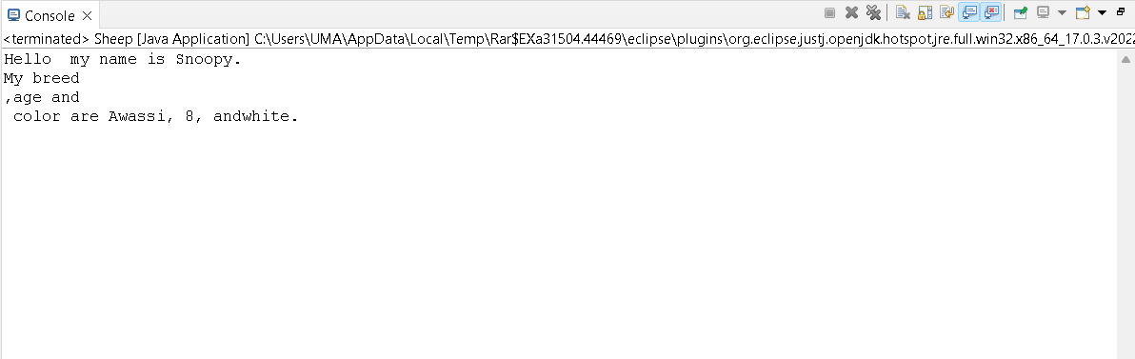

2.polymorphism

**package** com;

**class** User {

**static** **int** Multiply(**int** r, **int** s)

{

**return** r * s;

}

**static** **double** Multiply(**double** x, **double** y)

{

**return** x * y;

}

}

**public** **class** Polymorphism {

**public** **static** **void** main(String[] args)

{

System.***out***.println(User.*Multiply*(3, 5));

System.***out***.println(User.*Multiply*(3.3, 5.3));

}

}

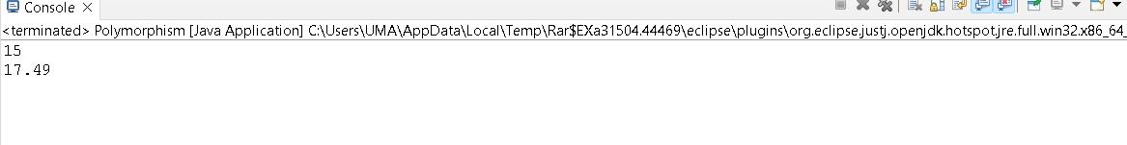

**3.Inheritance**

**package** com;

**class** AnimalType {

String name;

**public** **void** eat() {

System.***out***.println("I can eat biscuit");

}

}

**class** Dog **extends** AnimalType {

**public** **void** display() {

System.***out***.println("My Sweet name is " + name);

}

}

**public** **class** Inheritance {

**public** **static** **void** main(String[] args) {

Dog labrador = **new** Dog();

labrador.name = "LUCKY";

labrador.display();

labrador.eat();

}

}

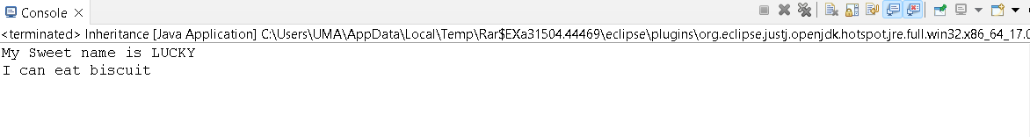

4.Encapsulation

**package** com;

**class** StudentDetails {

**private** **int** Student_Id;

**private** String name;

**public** **int** getId() {

**return** Student_Id;

}

**public** **void** setId(**int** s_id) {

**this**.Student_Id = s_id;

}

**public** String getname() {

**return** name;

}

**public** **void** setname(String s_name) {

**this**.name = s_name;

}

}

**class** Encapsulation {

**public** **static** **void** main(String[] args) {

StudentDetails s=**new** StudentDetails();

s.setId (2527434);

s.setname("Umalakshmi");

System.***out***.println("Student Data:" + "\nStudent ID:" + s.getId()

+ " Student Name:" + s.getname());

}

}



5.Abstraction

**package** com;

**abstract** **class** Animal {

**public** **abstract** **void** animalSound();

**public** **void** sleep() {

System.***out***.println("yyy");

}

}

**class** goat **extends** Animal {

**public** **void** animalSound() {

System.***out***.println("The goat says: may may");

}

}

**class** Abstraction {

**public** **static** **void** main(String[] args) {

goat mygoat = **new** goat();

mygoat.animalSound();

mygoat.sleep();

}

}

